Myra Wong
Mrs. Burakowski
Intro to Photography
27 April 2018
Gordon Parks
Gordon Parks, the proclaimed photographer, was incredibly passionate about documenting the lives of those who were often considered less than in society. Not only was he a photographer, he also worked as a composer, an author, and a filmmaker (Gordon Parks Foundation.) Most of his images involve messages pertaining to civil rights, racism, and poverty. His works have served as a great inspiration to many for how to incorporate a message or a story into photographs. He often took pictures of those who were victims of stereotyping, and he used his skill to tell the story of all his subjects and how the world may have been working against them.
Parks was born on November 30th, 1912 in Kansas and died March 7th, 2006 in New York at the age of 93. After his birth in Kansas, he moved to Minnesota but eventually died in New York. While he was working as a waiter he became inspired to become a photographer by portfolios in magazines. He was influenced by a photo of migrant workers in a magazine, and after seeing it he bought his first camera (Gordon Parks Foundation.) One of the most prominent and recent people he influenced is Kendrick Lamar, a highly distinguished rapper in today’s pop culture. In Lamar’s music video for a track titled ELEMENT he used imagery from Park’s famous photos to pay tribute to him (Nicholls.) Parks’ first camera was a Voigtlander Brillant. In his images I recreated he uses techniques such as sub framing, rule of thirds, and rule of space. He is most famous for his commentary on minorities in society with a focus on African Americans.
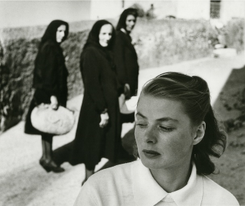
Parks, Gordon. Ingrid Bergman at Stromboli, Italy. Woodstock, 1949. Gelatin Silver Print
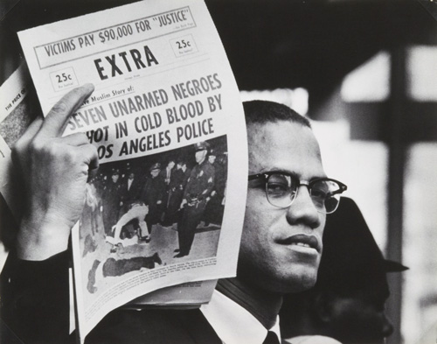
This first image, titled Ingrid Bergman at Stromboli, Italy, he depicts three elder women staring curiously at this young blonde woman who is clearly aware of their stares. The young blonde subject is a famous actress who was working on a film with a director whom she was having a love affair with. She left her spouse and child for this director and Parks was sent to get a picture of them together. Parks’ would reveal later that he has an opportunity to take a picture of them, but out of respect for their intimate moment of comfort, he decided to leave the scene (Mason.) In this photograph, Parks is putting an emphasis on Bergman’s vulnerability at this point in her life. The expression on Bergman’s face and the setup of the subjects really show how vulnerable she is. She looks all alone in her placement, and what makes it even more telling is that it is unposed. This image inspired me to set up my subjects in a different way in order to tell a story. It also encourages me to see the other side of a story.
Parks, Gordon. Malcolm X Holding Up Black Muslim Newspaper. Los Angeles, 1963.
This image titled Malcom X Holding Up Black Muslim Newspaper depicts a famous civil rights activist holding up a newspaper with a headline telling a story of police brutality. The 1960s was a time of great hardship for African Americans. Police brutality was a major issue that very few people cared about besides Black people and activists. Parks is making a statement about police brutality in this simple image. Simply with the headline he is telling us how prominent the issue of police brutality is, and he depicts his anger over that with this photo. I think Parks portrays the message clear as day. The viewer may as well be reading the message of this photo, and they pretty much can because of the headline in it. This photograph shows me how to use recent news events in my work and create a message out of that.

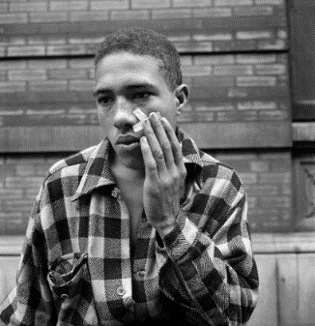
Parks, Gordon. Untitled. Harlem, 1948.
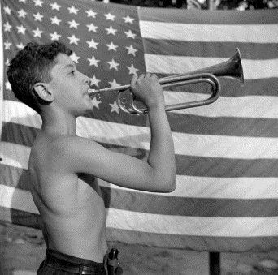
This image is untitled; it is a part of his photo essay titled “Harlem Gang Leader” which he took in 1948. In this image a man is pressing on a band aid on his face and staring off, his mind is clearly somewhere else. The photo essay documents the life of gang members in his neighborhood (“Gordon Parks: The Making of an Argument.”) Parks is able to disprove these stereotypes through his well thought out photos. This message was a little bit more difficult to see than the others. This message was a little bit more difficult to see than the others, but I believe the message here is about how painful the responsibility of his position is. This image influences me to be more personal with my subjects, and allows me to learn more about their life through these photos.
Parks, Gordon. Mess Call. Southfields (Orange County), New York, 1943.

This image is titled Mess Call and depicts a young boy holding a trumpet to his lips in front of the American flag. This boy is playing mess call at an interracial summer camp in New York while racial tensions were still high in America. I feel as though the flag is trying to convey the message that we are all Americans despite our skin color. Again, I believe the message could easily be misinterpreted, but that is the message I got from it. This image gives me new ideas for techniques and how I can incorporate different themes in my work.
Parks was able to send a message or make a statement with every photo through his subject’s expression and pose. His life growing up definitely lit the passion inside him to record in some way the life around him which included poverty and racial stereotypes. His messages were often based around civil rights and treating others as equals. He also made it a point to address the injustices occurring in America. Parks’ approach to photography shows me how to tell a story with just one subject and a couple of minor details. He is able to tell a story with the American flag, the band aid, and the newspaper. From his photographs, the viewer should be able to get a sense of the darker history of America, and they should be able to see that these issues have yet to meet a proper solution.

Works Cited
Gordon Parks Foundation. “Artist.” Gordonparksfoundation.org, www.gordonparksfoundation.org/artist.
“Gordon Parks: The Making of an Argument.” Gordon Parks: The Making of an Argument | BAMPFA,
BAMPFA, 3 Nov. 1970, bampfa.org/program/gordon-parks-making-argument.
Mason, John Edwin. “Ingrid Bergman: How a Photograph Never Made Led to Her Most Memorable
Portrait.” Time, 28 Aug. 2015, time.com/3998559/ingrid-bergman-gordon-parks-stromboli/.
Nicholls, Will. “New Kendrick Lamar Music Video Pays Tribute to Gordon Parks' Photos.” PetaPixel, 30
June 2017, petapixel.com/2017/06/30/kendrick-lama-music-video-pays-tribute-gordon-parks-photos/.

