Myra
Mrs. Burakowski
Foundations of Art
11 January 2017
Haring, Emin, and Saar’s Influence
Art has influenced the world by giving people a way to express themselves. Artists often show strong emotions in the art they create. Keith Haring, Tracey Emin, and Betye Saar give the viewer a glimpse into their life using art to convey their ideas and opinions. They are telling us about the issues they have faced in society. Each of the artists use different mediums and techniques as well as different motivations to create. These artists remind me to show my beliefs in my artwork. They inspire me to make my art mean something. Keith Haring, Tracy Emin, and Betye Saar express their emotions and beliefs on illness, relationships, and oppression through different pieces.
Keith Haring is an important artist with a unique and powerful perspective because he was a gay man at the time of the AIDS epidemic. He painted from firsthand experience about what was going on at the time. He was born in 1958 in Pennsylvania and died from AIDS in 1990 in New York City (Biography.com Editors). He had taken interest in art as a child and eventually went to college for commercial art. He dropped out because he was no longer interested in commercial art, but he did not stop creating. In fact, he had a solo exhibit before he moved to New York City and enrolled in School of Visual Arts. He was influenced by the accepting and vibrant art community around him and a number of artists. More specifically, he was inspired by Robert Henri's manifesto The Art Spirit (Keith Haring Foundation). He encouraged the public to raise awareness on the AIDS epidemic and destroy the stigma on homosexual relationships. He inspired the LGBT+ community and gave them a voice in art. He used many different mediums for his art including performance, video, installation, chalk and collage. He also stuck with drawing most of his life (Keith Haring Foundation). His work reminds me of pop art because of the bright colors and sharp, dark lines. It is vivid, captivating art that has an important message.
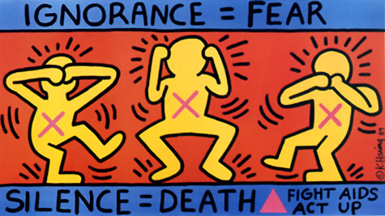
Haring, Keith. Ignorance = Fear. The Keith Haring Foundation New York, New York. http://www.haring.com/!/art-work/253#.WHV0JxsrLIU
He sends an important message through one of his works entitled Ignorance = Fear. He uses the famous “see no evil, hear no evil, speak no evil” in his piece where he is telling the viewer that if they are ignorant than they will be fearful, and that silence on this issue could mean death for many. Overall the piece is interesting for the viewer to see all while sending an important message. Haring uses thick black lines and bright, vivid colors to capture the attention of the public. Haring uses these lines to signify motion amongst the people in this piece. He uses contrasting colors such as blue and red or yellow and pink. The artist is trying to convey that silence about the AIDS epidemic means the death of those suffering. He is saying that those who are not educated on AIDS and HIV will be afraid of it just because they are ignorant on the subject. He wants people to educate themselves. Haring shows me that an art piece does not have to follow specific rules to send a message. His captivating art teaches me how to send an important message and make people listen.
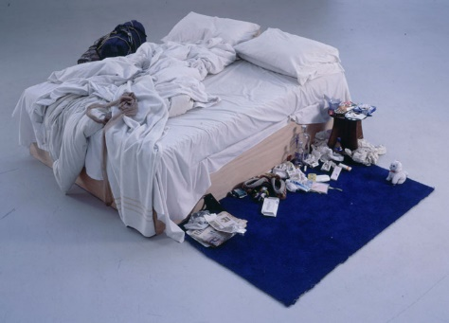
Another important artist is Tracey Emin and her many personal works. Her work is important because she is not afraid of exposure. She is not afraid to tell the truth or be explicit in her art pieces. She was born in 1963 in Croydon, South London, England and is still alive today. She moved to Medway, North Kent with her boyfriend and received her MFA from the Royal College of Art and moved to London. She studied fashion when she first went to college, but she was influenced by her boyfriend to join a performance art group which ultimately influenced her to strive to be an artist. Tracey Emin had a rough childhood which had a large impact on her work. She was raped at 13, and her family suffered financially because of a failed business (Biography.com Editors). She was also influenced by Expressionism and Contemporary artists like Bruce Nauman (Tracey Emin). She encourages people to find a way to express themselves. Emin seems to influence people to be their truest and most honest self. She uses many different techniques such as drawing, sculpting, film, photography, sewn applique, sculpture, and neon text with a main focus on painting (White Cube). Viewing her work is a very big step into her personal life. She uses many different mediums and techniques to express the mood or emotion of a piece. She makes a statement in every piece, and her works have a deeper story yet seem so simple.

Emin, Tracey. My Bed. Saatchi Gallery, London, England. https://www.saatchigallery.com/artists/artpages/tracey_emin_my_bed.htm
One piece of hers that made quite a statement is her piece My Bed. This piece is a representation of her bed displayed in filth but without shame. She puts her bed on display with underwear, used tissues, alcohol, cigarettes, and many more items of discussion. It looks as if she is going through a state of depression. Emin allows for movement throughout the piece; the eye moves naturally around the sheets and objects beneath them. She uses dull, light colors which seems to make the bed more depressing. She contrasts the bed with the rug and what seems to be a piece of luggage. The piece is actually a representation of her bed after a break up (Hannah Elis-Peterson). She claims she did not leave bed for days. Emin is trying to convey her depression and heart ache through the bed and all the story-telling items that surround it. Tracey Emin reminds me not to be afraid of giving a glimpse into my personal life. I can make my art personal using real life experiences or opinions.
Similar to Haring and Emin, Betye Saar is not afraid to make controversial art. Betye Saar is another important artist in culture today because she is an African-American artist whose pieces call out Americans for racism towards black people. This is something that is important to talk about especially in today's culture with the recent discussions over police brutality. She was born in 1926 in Los Angeles, California and is still living there today. She studied design at the University of California at Los Angeles and was inspired to broaden her horizon by other artists including Joseph Cornell who influenced her to work with three-dimensional objects (Biography.com Editors and The Editors of Encyclopedia Britannica). She encouraged change in society. Saar called out the discrimination black people face therefore influencing all who gazed upon her work and offering an important message with every item. Overall her work is extremely interesting to analyze. She uses real objects to convey a message meant for all of society to look at with deep thought.
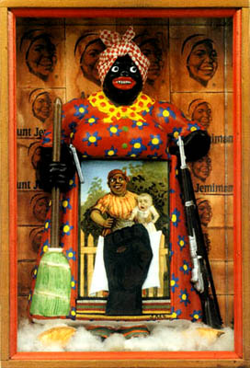
Saar, Betye. The Liberation of Aunt Jemima, 1972. Berkeley, California., by Roberts & Tilton, Culver City, California https://www.brooklynmuseum.org/eascfa/feminist_art_base/betye-saar
One of her more famous, thought-provoking assemblages is The Liberation of Aunt Jemima. This piece is changing stereotypes by taking a normally stereotypical character and empowering her with a shotgun. The piece is supposed to free her from the unjust laws and law enforcement that the artist was dealing with at the time. She puts an emphasis on the large doll in the middle holding a broomstick and a shotgun. The picture in the frame is a stereotypical mammy holding a white child. The large doll mammy holding the shotgun is supposed to be empowering this image of black women that people had in their mind at the time (Sally Whitman Coleman). There also seems to be an emphasis on the black fist in the center of the picture in the middle. The fist is a symbol for solidarity and support and is a reference to the Black Power Movement. The cotton at her feet points to the troubled past of black people in America; It points to white people living easier lives at the expense of black people. It has been discussed that Saar is trying to convey her anger over the lack of enforcement of voting laws and basic civil rights (Meredith Henry). The piece seems to go deeper in conveying gender roles and empowering black women using the broom in one hand and shotgun in the other. She shows me how I can use small items and still disclose my message. Most of all Betye Saar reminds me of all who are discriminated against and helps me remember them when creating social art.
These three artists remind me to make my art personal; they encourage me to have an important message when creating. These artists were struck with tragedy or great injustice and this affected their work in different ways. Some of their artwork was dark and depressing and others were vibrant and conveyed an important message. Haring showed the message that education can overcome fear. Emin conveyed that exposure is good, and people should not be afraid of their feelings. Saar conveyed that gender roles can be beaten, and racism will not be accepted. These artists' work has influenced me to use social issues and current events as a theme in my art. Their work has caused many including myself to grow angry over important issues. Showing your thoughts on social issues through art is a good way to get your message out there because it gives others a chance to relate it to their own lives. They taught me that if I am going to make anything, I should make it count.

Myra
Mrs. Burakowski
Foundations of Art
23 December 2016
Works Cited

"Betye Saar, The Liberation of Aunt Jemima, 1972." Arthistoryoftheday., 2011. https://arthistoryoftheday.wordpress.com/about/ Web. 23 Dec. 2016.
"Bio | Keith Haring." Bio | Keith Haring. http://www.haring.com/kh_foundation/authentication Sept. 2012, 22 Dec 2016. Web. 22 Dec. 2016.
Cube, White. "Tracey Emin." Artist | White Cube. 2012.,. http://whitecube.com/artists/tracey_emin/#!/artwork/my_bed/ Web. 22 Dec. 2016.
Ellis-Petersen, Hannah. "Tracey Emin's messy bed goes on display at Tate for first time in 15 years." The Guardian. Guardian News and Media, 2015. Web. 23 Dec. 2016.
Emin, Tracey. "Artist Q&A: Tracey Emin." Artist Q&A: Tracey Emin | Tate. 2004., http://www.tate.org.uk/learn/young-people/resources/careers-in-art/career-advice/artist- tracey-emin Web. 22 Dec. 2016.
Emin, Tracey. My Bed. Saatchi Gallery, London, England. https://www.saatchigallery.com/artists/artpages/tracey_emin_my_bed.htm
Haring, Keith. Ignorance = Fear. The Keith Haring Foundation New York, New York. http://www.haring.com/!/art-work/253#.WHV0JxsrLIU
"Keith Haring." Biography.com. A&E Networks Television, 2014. http://www.biography.com/people/keith-haring-246006 Web. 22 Dec. 2016.
Saar, Betye. The Liberation of Aunt Jemima, 1972. Berkeley, California., by Roberts & Tilton, Culver City, California https://www.brooklynmuseum.org/eascfa/feminist_art_base/betye-saar
"Tracey Emin." Biography.com. A&E Networks Television, 2015. http://www.biography.com/people/tracey-emin-20891535 Web. 22 Dec. 2016.

